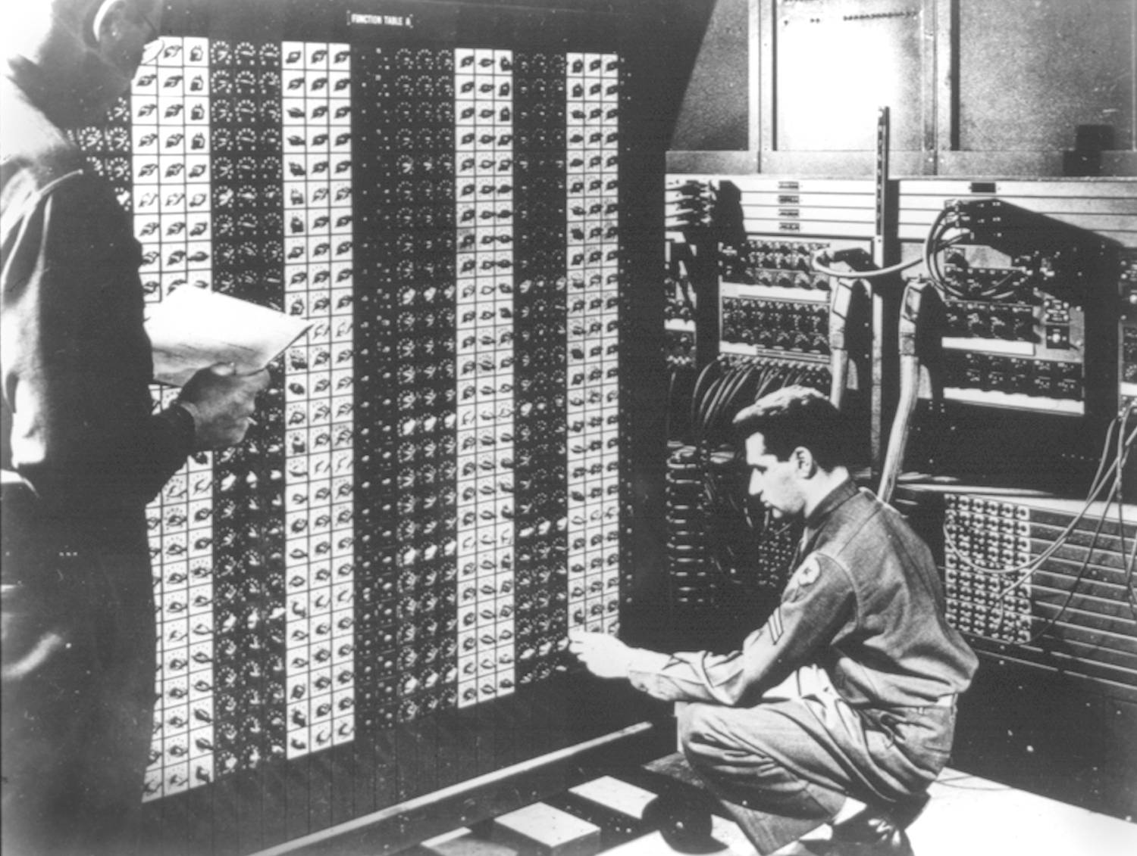 

**Advanced Placement Computer Science**

**Unit 1: Number Systems, Wrappers, DM Law**

Lesson: Class Location and Classpath

*Last Updated: 9/11/2015*

When working in java, there are several classes that ship as part of the java development kit or JDK.

Each one has a directory that it is organized within.

Core packages in Java SE 6[[edit](https://en.wikipedia.org/w/index.php?title=Java_package&action=edit&section=6)]

*Main article:*[*Java Platform, Standard Edition*](https://en.wikipedia.org/wiki/Java_Platform,_Standard_Edition)

|  |  |
| --- | --- |
| java.lang | — basic language functionality and fundamental types |
| java.util | — collection [data structure](https://en.wikipedia.org/wiki/Data_structure) classes |
| java.io | — file operations |
| java.math | — multiprecision arithmetics |
| java.nio | — the [New I/O](https://en.wikipedia.org/wiki/New_I/O) framework for Java |
| java.net | — networking operations, sockets, [DNS lookups](https://en.wikipedia.org/wiki/DNS_lookup), ... |
| java.security | — key generation, encryption and decryption |
| java.sql | — [Java Database Connectivity](https://en.wikipedia.org/wiki/Java_Database_Connectivity) (JDBC) to access databases |
| java.awt | — basic hierarchy of packages for native GUI components |
| javax.swing | — hierarchy of packages for platform-independent rich [GUI](https://en.wikipedia.org/wiki/GUI) components |
| java.applet | — classes for creating an applet |

1. Classes inside ___________________ do not need to be imported  
   These include
2. Classes outside this package need imports or full names
3. User defined classes can be used _________________________________________  
     
     
   Otherwise